How to watch detective Conan movies on Pops.vn
Pops.vn is known as one of the websites to watch detective Conan movies. However, there are quite a few people, especially those who first come to this website, are quite confused about how to find and watch movies here. If you too then please follow this article immediately!

1. Instructions on how to watch detective Conan movies at Pops.vn on the computer
- Step 1: Access Pops.vn
- Step 2: In the search bar at the top of the page, enter the words "Conan" -> Press enter
- Step 3: At the website interface, select Videos. Here will display all the videos about the famous detective Conan movie posted by the website
- Step 4: Select the episode you want to watch and enjoy

Watch Conan movie on the website Pops.vn

2. Account registration instructions and watch detective Conan film at Pops.vn

2.1. Sign up for an account
In addition to live view, you can also choose to register for an account to facilitate watching movies as well as purchasing service packages provided by this website. How to register as follows:
- Step 1: Access the link https://pops.vn/auth/signin-signup/signin
- Step 2: Choose to register your account by linking your Facebook or Google account. In addition, you can also choose Register to create a new account
- Step 3: If you want to create a new account by yourself, enter all information about Email, password -> Click Register
- Step 4: Check email. Pops will now send you an email to the email account used to sign up. You open the mail and get the confirmation code then enter the information box -> Click Activate
- Step 5: Optimize your account for the best experience at Pops by setting:
  - Profile Adult: Adult account
  - Profile Kids: Account for children
For example, you choose Profile Adult, the interface will display entertainment items such as: Home, Music, E! Zone, Children, Other. You click on each category -> Go to classification -> Choose your favorite program

2.2. Watching movies at Pops.vn
You can search for detective Conan movies by scrolling down to find a movie at the home interface or entering the word "Conan" into the magnifying glass search toolbar at the top -> Press Enter. Immediately the videos about detective Conan show. You can select the episode you want to watch by left-clicking on that video.
During the video viewing process, you can use functions such as Play / Pause, switch to other videos, increase / decrease the volume, zoom in and out of the screen.

View detective Conan at Pops

3. How to install the Pops app for your phone to watch detective Conan movies
You can also install the Pops app for your phone so you can watch detective Conan movies anytime, anywhere by:
- Step 1 : Go to App store (iOS phone) or Play Store (Android phone)
- Step 2: At the interface on the phone, click the arrow icon on the right to download the application and install as when installing the Other applications
- Step 3: After the installation is completed, access the application using your Facebook or Google linked account. In addition, you can also register a new account at Pops for more convenient management.
- Step 4: To register a new account on the Pops app at your phone is basically the same as when registering an account. As we have guided above
- Step 5: To watch detective Conan movies, you also enter the search box "Conan" -> Click search and select the episode you want to see

Install Pops app for phone

4. How to install Pops app and watch detective Conan on Samsung Smart TV
Besides watching detective Conan movies at Pops.vn on computers, phones, and iPads you can also watch on smart TV. How to install Pops for smart TV and watch Conan movies on this device is as follows:
- Step 1: Connect smart TV to the internet
- Step 2: Register or sign in your Samsung Account by pressing the button icon of the house on the remote -> Select Apps -> Click the Sign in icon on the screen -> Select Login -> Enter your username and password -> Click Sign In
- Step 3: Download and install Pops app for smart TV by going to Apps -> Press the search icon -> Enter Pops app name -> Select Settings and wait a moment to download the app to your device -> Once the download is finished select Add to my screen
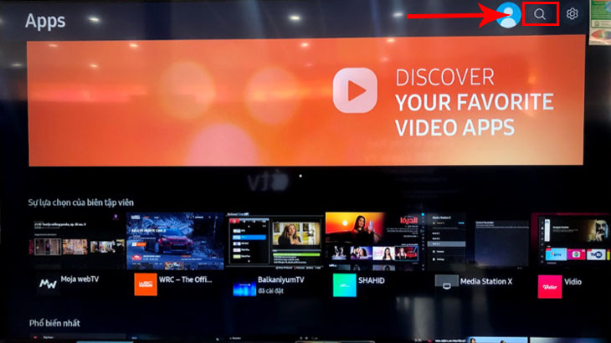
Set Set apps for smart TV
- Step 4: Open the app and enter the search bar with the words "Conan" -> Click Search, you have found the detective Conan episodes posted on Pops. Now just use the remote to select the episode you want to watch.

Above are detailed instructions on how to watch detective Conan movies at Pops. Watching movies at Pops ensures extremely sharp, high-resolution image quality, Conan movies are always updated fastest. In particular, Pops can be compatible with many devices, making watching movies much easier and convenient. If you want to be able to follow the full set of famous detective Conan, download Pops' application for the device.

